The Texas Dairy Co.
Institution
Course
Name

Introduction
The Texas Dairy Co. will be a small multinational company that will be operating from Texas, US. The company will be dealing with dairy products that will be produced in the US and sold to Kuwait. The Kuwait market for dairy farm products seems to have grown at a faster rate than ever before. Therefore, there is a need to capture the growing market within the Kuwait dairy market. The company will be dealing with dairy products such as milk, yogurt, cheese, and ice cream dairy products. The dairy market is characterized by local, regional, and international business players (OECD, & FAO. 2019). Therefore, the market is highly competitive but it has been noted that the market will be expected to register a value of US $13.5 billion by 2024.
Distribution of the Products
The distribution process involves bringing goods and services closer to the consumers. Texas Dairy Co. will distribute its dairy products through a distributor based in Kuwait. This will simplify the process of supplying the products within the market in Kuwait. Al Babtain is the distributor that the company will be using to distribute its products to the places where they are required. The distributor is well established and deals with local as well as international manufacturers to avail products to the consumers whenever they need them. The distributors deal with dairy products such as beverages, buttermilk, and yogurt among other dairy products.
Market Overview
Kuwait dairy product market has been doing well over the last few decades. The same trend has been projected to keep on progressing into the future. With that having been said, it is clear that the market will expand and hence there will be a need to have an external supplier to come up and supply dairy products (OECD, et al., 2019). The Kuwait dairy products market has been projected to reach a value of US $13.5 billion by 2024. The Kuwaitis have turned to be health-conscious and this has made them start looking for products that will be good for their health (FOOD & AGRICULTURE ORG, 2019). Such products include fresh milk, sour milk, yogurt, and some other dairy products. Dairy products are associated with functional attributes and thus, there will be a market for dairy products that will be produced by the Texas Dairy Co.
The company will have a farm where it will be getting over fifty-percent of the supply of its raw material – will have its dairy cows. The remaining around fifty-percent will be supplied by individual farmers who will be monitored by the company’s experts. This will be to ensure that the farmers have followed the set procedures to ensure high-quality raw products are delivered into the company. Besides, there will be expenses incurred in terms of dollars and Kuwait Dinar (KD).
Country Factors Affecting the Demand for Dairy Products
Inflation, Foreign Currency Reserves and Exchange Rates
Exchange Rates; a national currency that appears to have appreciated significantly might increase the cost-competitiveness of those who need to export products thus getting themselves in a position where they are outdone within the export markets (Madura, J., & Fox, 2007). The value of Kuwait Dinar against the US Dollar appears to have been stable over the last two years. Currently, the Kuwait Dinar is exchanging at a rate of 1 KD equals US$3.25.
Foreign Currency Reserves; to have a country competing efficiently in competitive worldwide markets, a country must have the type of technology which will improve productivity and which might be challenging if reserves in the forex are inadequate. There seems to be an upward trend in terms of Kuwait Dinar which is held in the US reserves. There also appears to be a significant amount of US dollars that are being held in the foreign reserves in Kuwait.
Inflation; if inflation is progressing rampantly in a nation, the cost of producing a single unit of a good might be higher compared to the price of the same unit in a lower-inflation nation (Madura, et al., 2007). However, the rate of inflation in Kuwait is low and thus products that are produced within the country will be sold at a profit.
Demand
The demand for a certain product is an important component of international trade. Since Kuwaitis have resulted in becoming health conscious, there will be an increase in demand for goods that are fit health-wise. Dairy products are some of the products that are fit for human consumption. This coupled with the fact that the Kuwait dairy product market has been projected to expand in the future will provide a market for the products which will be produced by Texas Dairy Co.
Trade Policies
Countries put in place trade policies that are meant to control the entry of imports. The price of the imported products is relatively increased by the introduction of import quotas, which in return decreased their demand. Subsidies also affect demand in various ways (Madura, et al., 2007). For instance, agricultural subsidies will decrease the cost of agricultural products and thus reassuring additional products for export. Having said that, it appears that the US and Kuwait have been trading for a long period. Agricultural imports seem to have increased over the last few years. This is a clear indication that the Texas Dairy Co. will have a market in Kuwait where it can sell its agricultural products.
The factor that would affect the demand for dairy products is trade policies. A country puts in place trade policies that are meant to protect the home-based industries. The country has in place a clear procedure that the companies that need to export their products into the nation have to fill (Madura, et al., 2007). In case, one fails to fill in the correct way, it might take longer to export its products to the country. On the other hand, dairy products are not part of the country’s main export. Kuwait exports oil and other chemicals. Thus, this nation is a good place to search for the market for dairy products.
Foreign Exchange Market
The spot is the most common product that involves buying and selling of currencies at the existing interest rates and it is sold directly to the customers. In this case, Texas Dairy Co. will contact the National Bank of Kuwait and enquire about the interest rates (Hull & Basu, 2010). Once the company has got the prevailing interest rates, then it can buy the required Kuwait dinar to enable it to do transactions. The most recent rate of Kuwait dinar against the US dollar is 1KD = US$3.25.
Forward
The forward rate refers to an interest rate which is applied to future financial transaction (Hull, et al., 2010). For the Texas Dairy Co., the company will need to buy the KD and deposit it at its account. This will help the company in mitigating the risk of loss. However, before such a decision is made, the company’s management team dealing with foreign exchange must have projected that the Kuwait dinar might increase in value against the US dollar. The FX exchange rate keeps on changing and therefore the company has to keep track of the trends in the value of Kuwait dinar. Forward is a great hedging tool that is used to help in mitigating such risks.
Schedules in the Foreign Currency’s Value
Factors affecting the value of Kuwait dinar include:
- Inflation Rates
Exchange rate changes are brought about by changes in market inflation. The value of a currency belonging to a nation that is experiencing lower inflation appreciates. The value of the products will in return surge at a lower rate (Madura, et al., 2007). In this case, the price of the products has to be lower since both nations do not experience high rates of inflation.
- Interest Rates
Changes in interest rates affect the value of Kuwait’s dinar and that of the US dollar. Forex rates, interest rates, and inflation rates are all interrelated. Therefore, an increase in interest rates will make a nation’s currency to increase its value since the greater interest rates which will provide greater rates to the creditors and thus enticing to make foreign investors continue increasing their investment which will in return make the exchange rates to go high.
- The Country’s Current Account
A country’s balance of payments shows the balance of trade and earnings got from foreign investment. The value of the currency is negatively affected if the nation happens to spend more of its currency in imports.
- Political Stability and Performance
A country’s political state as well as its economic performance affects the strength of its currency. A nation that has a low likelihood of experiencing political turmoil will be attractive to investors from foreign nations. With that having being said, Kuwait is a peaceful country and that it attracts foreign investors. If foreign capital increases, it will in return lead to an increase in value in the value of its domestic currency. However, the exchange rate of KD against US $ appears to be stable. This is a clear indication that the company can be able to trade with the nation profitably.
Applying Currency Futures and Options
Options
An option refers to a derivative tool which is used for hedging. FX options allow the clients to have their currencies exchanged in the future at an agreed time and rate. Therefore, if the necessary projections are done, then it will be easier for the company to divert or mitigate the risks that might have been experienced and use the currency at a time when they are required. In this case, the Texas Dairy Co. will obtain the KD whenever they are needed or obtain them earlier so that the company can use the currency in the future when they have predicted the value will have appreciated by then.
Futures
Organizations might use futures contracts to help mitigate certain risks that they might face in the future. For the case of the Texas Dairy Co., the business might use currency futures to offset certain risks in the changes of value of the currency. The company will be paid for KD and thus it has to be very careful with the value of the currency. Through the application of the futures, the company will be able to lock a certain amount of the Kuwait dinar in its exchange rate.
Monitoring Central Bank Intervention
Currency values differ from one currency to the other. The currencies that are involved in this case are the US dollar and Kuwait dinar. The US dollar is the world’s largest currency and its value is strong. However, the US dollar is not as strong as the Kuwait dinar. The business country being in Kuwait, in case the fed increases the transnational value of the dollar will decrease Kuwait dinar’s value. The sales and revenues of the Texas Dairy Co. will be negatively impacted. The company’s profitability will at the end of any given transaction period decrease given that the dollar value is strengthened against the Kuwait dinar. On the other hand, in case the fed decides to weaken the dollar against the Kuwait dinar, the transnational value of the US dollar will increase the prevailing value of the Kuwait dinar. This will in return translate to more profits for the company. This case will result because the dairy products sold in the Kuwait market will turn to be cheaper and the Kuwaitis will be able to earn more sales and therefore an increase in the profits being earned by the company. The indirect intervention by the central bank affects the business even if there is no impact on the exchange rate. For instance, to increase the value of the Kuwait home currency, the central bank of Kuwait could make attempts to upsurge the interest rate thereby making the alien demand for the Kuwait dinar to buy the high yield securities.
Assessing Spot and Forward Rates
The National Bank of Kuwait
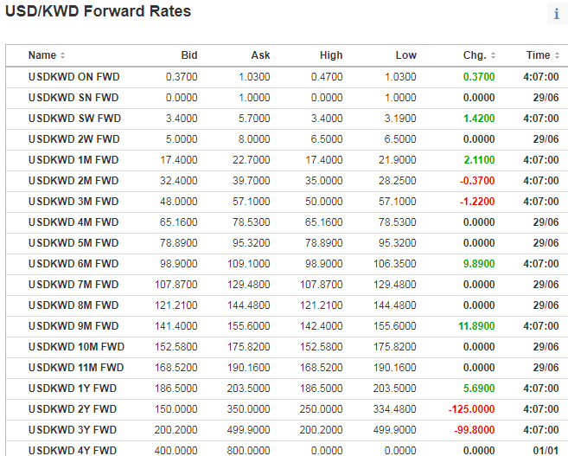
Link: https://www.investing.com/currencies/usd-kwd-forward-rates
The Central Bank of Kuwait
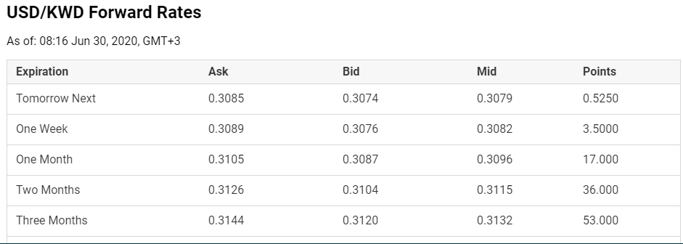
Link: https://www.fxempire.com/currencies/usd-kwd/forward-rates
From the look of the data, it can be asserted that interest rate parity exists. For the National Bank of Kuwait, the interest rate for the first case is 35.92% and for the Central Bank of Kuwait, the rate is 19.44%.
Spot Rates
National Bank of Kuwait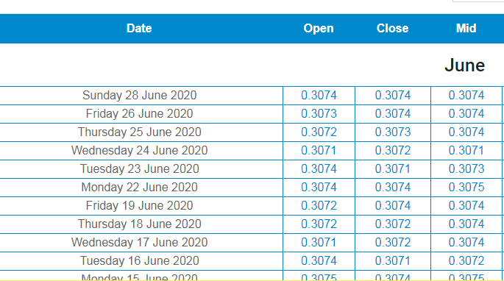
Link: https://www.exchangerates.org.uk/KWD-USD-exchange-rate-history.html
Commercial Bank of Kuwait
Date | Open | Close | Mid
28/6/2020 | 0.3068 | 0.3068 | 0.3068
26/6/2020 | 0.3069 | 0.3069 | 0.3069
25/6/2020 | 0.3070 | 0.3070 | 0.3070
24/6/2020 | 0.3070 | 0.3068 | 0.3069
23/6/2020 | 0.3071 | 0.3072 | 0.3074
22/6/2020 | 0.3074 | 0.3071 | 0.3072
19/6/2020 | 0.3072 | 0.3072 | 0.3074

Link: https://www.cnbc.com/quotes/?symbol=KWD=
From the above data, it seems that the spot rates are almost affiliated across locations at a given point in time. The above data indicates that the spot rates are close at all times between the two banks.
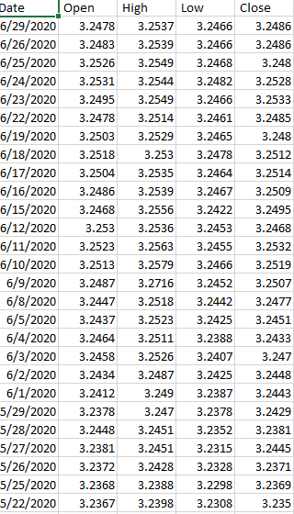
Link: https://www.wsj.com/market-data/quotes/fx/KWDUSD/historical-prices
It seems from the above data that the forward rate of the foreign currency shows a premium when its interest rate is lower compared to the US interest rate.
Determining if the IFE Holds
Date | Open | High | Low | Close | interest rate differential
First Quarter 2020 | 3.2478 | 3.2537 | 3.2466 | 3.2486 | 0.0059
 | 3.2483 | 3.2539 | 3.2466 | 3.2486 | 0.0056
 | 3.2526 | 3.2549 | 3.2468 | 3.248 | 0.0023
 | 3.2531 | 3.2544 | 3.2482 | 3.2528 | 0.0013
 | 3.2495 | 3.2549 | 3.2466 | 3.2533 | 0.0054
 | 3.2478 | 3.2514 | 3.2461 | 3.2485 | 0.0036
 | 3.2503 | 3.2529 | 3.2465 | 3.248 | 0.0026
 | 3.2518 | 3.253 | 3.2478 | 3.2512 | 0.0012
Final quarter 2019 | 3.2504 | 3.2535 | 3.2464 | 3.2514 | 0.0031
 | 3.2486 | 3.2539 | 3.2467 | 3.2509 | 0.0053
 | 3.2468 | 3.2556 | 3.2422 | 3.2495 | 0.0088
 | 3.253 | 3.2536 | 3.2453 | 3.2468 | 0.0006
 | 3.2523 | 3.2563 | 3.2455 | 3.2532 | 0.004
 | 3.2513 | 3.2579 | 3.2466 | 3.2519 | 0.0066
 | 3.2487 | 3.2716 | 3.2452 | 3.2507 | 0.0229
 | 3.2447 | 3.2518 | 3.2442 | 3.2477 | 0.0071
Third Quarter 2019 | 3.2437 | 3.2523 | 3.2425 | 3.2451 | 0.0086
 | 3.2464 | 3.2511 | 3.2388 | 3.2433 | 0.0047
 | 3.2458 | 3.2526 | 3.2407 | 3.247 | 0.0068
 | 3.2434 | 3.2487 | 3.2425 | 3.2448 | 0.0053
 | 3.2412 | 3.249 | 3.2387 | 3.2443 | 0.0078
 | 3.2378 | 3.247 | 3.2378 | 3.2429 | 0.0092
Second quarter 2019 | 3.2448 | 3.2451 | 3.2352 | 3.2381 | 0.0003
 | 3.2381 | 3.2451 | 3.2315 | 3.2445 | 0.007
 | 3.2372 | 3.2428 | 3.2328 | 3.2371 | 0.0056
 | 3.2368 | 3.2388 | 3.2298 | 3.2369 | 0.002
 | 3.2367 | 3.2398 | 3.2308 | 3.235 | 0.0031
After having reviewed the exchange rate percentage change in Kuwait’s Dinar over each of those conforming quarters, it is clear that the IFE seems to hold over the above quarters for the US dollar.
Checking Exchange Rate Trends

Date | Open | High | Low | Close | interest rate differential | percentage change
6/29/2020 | 3.2478 | 3.2537 | 3.2466 | 3.2486 | 0.0059 | 0.949153
6/26/2020 | 3.2483 | 3.2539 | 3.2466 | 3.2486 | 0.0056 | 0.410714
6/25/2020 | 3.2526 | 3.2549 | 3.2468 | 3.248 | 0.0023 | 0.565217
6/24/2020 | 3.2531 | 3.2544 | 3.2482 | 3.2528 | 0.0013 | 4.153846
6/23/2020 | 3.2495 | 3.2549 | 3.2466 | 3.2533 | 0.0054 | 0.666667
6/22/2020 | 3.2478 | 3.2514 | 3.2461 | 3.2485 | 0.0036 | 0.722222
6/19/2020 | 3.2503 | 3.2529 | 3.2465 | 3.248 | 0.0026 | 0.461538
6/18/2020 | 3.2518 | 3.253 | 3.2478 | 3.2512 | 0.0012 | 2.583333
6/17/2020 | 3.2504 | 3.2535 | 3.2464 | 3.2514 | 0.0031 | 1.709677
6/16/2020 | 3.2486 | 3.2539 | 3.2467 | 3.2509 | 0.0053 | 1.660377
6/15/2020 | 3.2468 | 3.2556 | 3.2422 | 3.2495 | 0.0088 | 0.068182
6/12/2020 | 3.253 | 3.2536 | 3.2453 | 3.2468 | 0.0006 | 6.666667
6/11/2020 | 3.2523 | 3.2563 | 3.2455 | 3.2532 | 0.004 | 1.65
6/10/2020 | 3.2513 | 3.2579 | 3.2466 | 3.2519 | 0.0066 | 3.469697
6/9/2020 | 3.2487 | 3.2716 | 3.2452 | 3.2507 | 0.0229 | 0.310044
6/8/2020 | 3.2447 | 3.2518 | 3.2442 | 3.2477 | 0.0071 | 1.211268
6/5/2020 | 3.2437 | 3.2523 | 3.2425 | 3.2451 | 0.0086 | 0.546512
6/4/2020 | 3.2464 | 3.2511 | 3.2388 | 3.2433 | 0.0047 | 1.446809
6/3/2020 | 3.2458 | 3.2526 | 3.2407 | 3.247 | 0.0068 | 0.779412
6/2/2020 | 3.2434 | 3.2487 | 3.2425 | 3.2448 | 0.0053 | 1.471698
6/1/2020 | 3.2412 | 3.249 | 3.2387 | 3.2443 | 0.0078 | 1.179487
5/29/2020 | 3.2378 | 3.247 | 3.2378 | 3.2429 | 0.0092 | 0.032609
5/28/2020 | 3.2448 | 3.2451 | 3.2352 | 3.2381 | 0.0003 | 23.33333
5/27/2020 | 3.2381 | 3.2451 | 3.2315 | 3.2445 | 0.007 | 0.8
5/26/2020 | 3.2372 | 3.2428 | 3.2328 | 3.2371 | 0.0056 | 0.357143
5/25/2020 | 3.2368 | 3.2388 | 3.2298 | 3.2369 | 0.002 | 1.55
5/22/2020 | 3.2367 | 3.2398 | 3.2308 | 3.235 | 0.0031 | 1.096774
5/21/2020 | 3.2382 | 3.2416 | 3.2343 | 3.2372 | 0.0034 | 2.794118
5/20/2020 | 3.2325 | 3.242 | 3.2325 | 3.2378 | 0.0095 | 0.642105
5/19/2020 | 3.2362 | 3.2423 | 3.2304 | 3.2328 | 0.0061 | 1.245902
5/18/2020 | 3.2342 | 3.2418 | 3.23 | 3.2358 | 0.0076 | 0.118421
5/15/2020 | 3.241 | 3.2419 | 3.2278 | 3.2362 | 0.0009 | 7.444444
5/14/2020 | 3.2346 | 3.2413 | 3.2295 | 3.2413 | 0.0067 | 1.029851
5/13/2020 | 3.2313 | 3.2382 | 3.231 | 3.2339 | 0.0069 | 0.710145
5/12/2020 | 3.2326 | 3.2375 | 3.226 | 3.2319 | 0.0049 | 8.877551
5/11/2020 | 3.2303 | 3.2738 | 3.2293 | 3.2332 | 0.0435 | 0.183908
5/8/2020 | 3.2327 | 3.2407 | 3.2288 | 3.2303 | 0.008 | 2.1625
5/7/2020 | 3.2248 | 3.2421 | 3.2233 | 3.2332 | 0.0173 | 0.242775
5/6/2020 | 3.2344 | 3.2386 | 3.223 | 3.2242 | 0.0042 | 0.619048
5/5/2020 | 3.2393 | 3.2419 | 3.2304 | 3.2341 | 0.0026 | 12.80769
5/4/2020 | 3.2334 | 3.2667 | 3.226 | 3.2386 | 0.0333 | 0.159159
5/1/2020 | 3.2328 | 3.2381 | 3.2238 | 3.2334 | 0.0053 | 1.528302
4/30/2020 | 3.232 | 3.2401 | 3.2229 | 3.233 | 0.0081 | 2.641975
4/29/2020 | 3.2163 | 3.2377 | 3.2157 | 3.2314 | 0.0214 | 0.985981
4/28/2020 | 3.2171 | 3.2382 | 3.2157 | 3.2166 | 0.0211 | 0.36019
4/27/2020 | 3.2162 | 3.2238 | 3.2072 | 3.2173 | 0.0076 | 0.763158
4/24/2020 | 3.2191 | 3.2249 | 3.2034 | 3.2162 | 0.0058 | 2.586207
4/23/2020 | 3.2067 | 3.2217 | 3.2016 | 3.2194 | 0.015 | 0.373333
4/22/2020 | 3.2066 | 3.2122 | 3.1967 | 3.2073 | 0.0056 | 1.517857
4/21/2020 | 3.2128 | 3.2213 | 3.2022 | 3.2072 | 0.0085 | 1.223529
4/20/2020 | 3.2091 | 3.2195 | 3.2038 | 3.2131 | 0.0104 | 2.182692
4/17/2020 | 3.2041 | 3.2268 | 3.2033 | 3.2091 | 0.0227 | 1.634361
4/16/2020 | 3.2081 | 3.2452 | 3.1945 | 3.2038 | 0.0371 | 0
4/15/2020 | 3.2169 | 3.2169 | 3.1987 | 3.2086 | 0 | 0
4/14/2020 | 3.2087 | 3.2485 | 3.199 | 3.2163 | 0.0398 | 0.643216
4/13/2020 | 3.2145 | 3.2401 | 3.2038 | 3.209 | 0.0256 | 0.683594
4/10/2020 | 3.2011 | 3.2186 | 3.1996 | 3.2145 | 0.0175 | 1.497143
4/9/2020 | 3.2082 | 3.2344 | 3.1978 | 3.2007 | 0.0262 | 1.156489
4/8/2020 | 3.2069 | 3.2372 | 3.1978 | 3.2075 | 0.0303 | 0.785479
4/7/2020 | 3.2 | 3.2238 | 3.1997 | 3.2072 | 0.0238 | 0.991597
4/6/2020 | 3.2152 | 3.2388 | 3.1965 | 3.1997 | 0.0236 | 0.758475
4/3/2020 | 3.2107 | 3.2286 | 3.2002 | 3.2199 | 0.0179 | 1.810056
4/2/2020 | 3.2079 | 3.2403 | 3.1886 | 3.2101 | 0.0324 | 0.651235
4/1/2020 | 3.1883 | 3.2094 | 3.1636 | 3.2076 | 0.0211 | 34.52133
 |  |  |  | Total | 0.7284 | 158.1862
 |  |  |  | mean | 0.011381 | 2.471659
Link: https://www.wsj.com/market-data/quotes/fx/KWDUSD/historical-prices
The mean percentage change over time is 2.471659. Following this means, it appears that the currency’s value will devalue some days to come.
Identifying Exposure to Exchange Rate Risk
Supplier Payments; when the company will be paying a supplier, it is the exchange rate exposure that will affect the company. If for instance, the suppliers back in the US will be paid in six months, every percentage of change in the US$/KD rate will have a direct effect on the business’s bottom line.
Sales Forecasts; since this is a multinational company, sales forecasts can be either a motivator or hindrance. At times the firm’s sales that are listed in another currency might face a rough time when the exchange rate turns against the currency. In this case, in case the KD turns against the US $ then the sales of Texas Dairy Co. might turn into pennies.
The Texas Dairy Co. might in the future encounter transaction exposure. This is the level of uncertainty since the company is taking part in international trade. Particularly, it is the danger that the currency exchange rates will keep on changing after the company has already supplied its products. The company is also subject to economic exposure. Economic exposure refers to an effect that is caused by a business’s cash flows after exchange rates of currency changes. The company is also subject to translation exposure. This is the risk where a firm’s liabilities, equities, assets, or income will change in value due to fluctuations in the exchange rates.
Hedging with Forwarding Contracts
Forward
The forward rate refers to an interest rate that is applied to a future financial transaction. For the Texas Dairy Co., the company will need to buy the KD and deposit it at its account. This will help the company in mitigating the risk of loss. However, before such a decision is made, the company’s management team dealing with foreign exchange must have projected that the Kuwait dinar might increase in value against the US dollar (Flood, 2018). The FX exchange rate keeps on changing and therefore the company has to keep track of the trends in the value of Kuwait dinar. Forward is a great hedging tool that is used to help in mitigating such risks.
Options
An option refers to a derivative tool which is used for hedging. FX options allow the clients to have their currencies exchanged in the future at an agreed time and rate. Therefore, if the necessary projections are done, then it will be easier for the company to divert or mitigate the risks that might have been experienced and use the currency at a time when they are required (Flood, 2018). In this case, the Texas Dairy Co. will obtain the KD whenever they are needed or obtain them earlier so that the company can use the currency in the future when they have predicted the value will have appreciated by then.
Denominating Receivables in American Dollars
The Texas Dairy Co. is in a position to encounter transaction exposure. This is the level of uncertainty since the company is involved in worldwide trade. Particularly, it is the risk that the legal tender exchange rates will keep on changing after the company has already supplied its products. In the case that the US dollar is dominating the KD, the business’s transaction exposure will be reversed and the company will earn profits in case it had supplied goods earlier. However, the business’s performance will be impacted by supplier payments.
Creating a Subsidiary in Foreign Nation
Setting up a foreign subsidiary creates a legal entity in the other country. Legal business entities that are established in a foreign are in a position of marketing their products to the locals. They are also in a position to import and export products (Sercu, 2011). Besides, a business that has a local presence is placed in a position where it can expand its brand recognition to new markets so that it can increase its sales volume and ultimately its profits.
Setting up a subsidiary firm in foreign markets has some setbacks. One of the setbacks in this case is that of increased cost and time (Sercu, 2011). Establishing a foreign subsidiary often involves the consumption of time and money. Another factor that can act as a setback, in this case, is that of complex compliance requirements. For instance, the firm could come across tax requirements and complex rules that are linked to hiring staff. However, in this case, the rules related to hiring employees will not affect the company since it is privately owned and most of the Kuwaitis work under their government.

References
Flood, J. M. (2018). Wiley GAAP 2018: Interpretation and Application of Generally Accepted Accounting Principles. New York, NY: John Wiley & Sons.
FOOD, A. N. D. A. G. R. I. C. U. L. T. U. R. E. O. R. G. A. N. I. Z. A. T. I. O. N. O. F. T. H. E. U. N. I. T. E. D. N. A. T. I. O. N. S. (2019). FOOD OUTLOOK - BIANNUAL REPORT ON GLOBAL FOOD MARKETS. S.l.: FOOD & AGRICULTURE ORG.
Hull, J. C., & Basu, S. (2010). Options, futures and other derivatives. New Delhi: Pearson.
Madura, J., & Fox, R. (2007). International financial management. London: Thomson Learning.
OECD, & FAO. (2019). OECD-FAO Agricultural Outlook 2019-2028.
Sercu, P. (2011). International Finance: Theory into Practice. Princeton: Princeton University Press.

